**Abstract**

The Student Management System is a computer program aimed at simplifying the management of student data, such as enrollment, attendance, grades, and other information. The current manual system has various drawbacks, including errors, delays, and lack of transparency. This motivated the development of this project, which aims to automate and streamline the student management process by providing a centralized and secure platform. This system will allow teachers to easily update grades and attendance records, while providing students with real-time access to their information. The end goal is to improve the efficiency and accuracy of the student management process.

Requirement Specification which includes hardware, software requirements along with functional requirements. Designing the database for data storage of the students. Creating ER diagram and Schema Diagram for designing the database.

Implementation of created design having a frontend build using HTML, CSS and JavaScript. SQL database connected through flask and SQL-alchemy.

Understanding how Database is designed according to the requirements provided.

How to design a conceptual view through an ER diagram and convert it into a Scheme diagram. Applying the concept of normalization to convert the relations to normal forms.

**Table of Contents**

**Acknowledgement i**

**Abstract ii**

**Table of Contents iii**

**List of Figures iv**

**Glossary**

1. Introduction Page No.

* 1. Introduction 1
  2. Objectives 1
  3. Scope 1

1. Software Requirement Specification
   1. Software Requirements 3
   2. Hardware Requirements 3
   3. Functional Requirements 3
2. ER Diagram 4
3. Detailed Design
   1. Data Flow Diagram
      1. DFD Level 0 5
      2. DFD Level 1 5
      3. DFD Level 2 6
4. Relational Schema and Normalization 7
5. NoSQL 11
6. Conclusion & Future Enhancement 12

References 13

Appendix: Snapshots 14

**List of Figures**

**Figure No. Figure Name Page No.**

**3.1**  ER Diagram 4

**4.1** DFD Level 0 5

**4.2** DFD level 1 5

**4.3** DFD level 2 6

**5.1**  Schema diagram 7

**6.1** MongoDB compass 11

**GLOSSARY**

DFD : Data flow diagram

ER diagram : Entity Relationship diagram

IDE : Integrated development environment

NF : Normal Form

SMS : Student Management System

SQL : Structured Query Language

SRS : Software Requirement Specification

## CHAPTER 01:

**Introduction**

## 1.1Introduction:

Student management system which is easy to use and an efficient computerized system to develop an accurate and flexible system, it will eliminate data redundancy. This system saves the time of the student and of the administrator. It includes processes like registration of the student’s details, assigning the department based on their course, and maintenance of the record. Every student detail can be fetched along with the attendance. It shows in particular course marks and which faculty is handling that course. This system reduces the cost and workforce required for this job.

## Scope of the project

The Student Management System proposed here introduces several key features to address the limitations of existing systems. It includes:

* Student Registration: The system can handle student registration and enrollment, including the creation of student profiles and the collection of required information.
* Student Information: The system can store and manage student information such as personal details, academic records and contact information.
* Attendance Management: the system can track attendance and generate reports on attendance trends.
* Grade Management: The system can store and manage grades and other academic data and generate reports.
* Course Management: The system can manage course schedules and also students can

enroll in any of the courses.

* Enrollment tracking: The system can track student enrollment status, including current enrollment and enrollment history.
* Access control: The system can control access to different parts of the system, based on user roles and permissions.
* Communication: The system can facilitate communication between students, teachers and administrators.

**1.3 Objectives**

* The main objective of the project is to design and develop a user friendly-system.
* To develop an accurate and flexible system, it will eliminate data redundancy.
* To study the functionality of the student’s management System.
* To make software with a good user interface so that users can change it and it should be used for a long time without error and maintenance.

**CHAPTER 02:**

**Software Requirement specification**

A Software and Hardware requirements specification is a document that outlines the functional and non-functional requirements of a software project. It is a formal document that describes in detail what the software should do and how it should perform.

# 2.1 Software Requirements:

* Frontend- HTML, CSS, Java Script, Bootstrap
* Backend -Python flask (Python 3.7), SQL Alchemy.
* Operating System: Windows 10
* Google Chrome/Internet Explorer
* XAMPP (Version-3.7)
* IDE: Visual Studio code (user interface)

## 2.2 Hardware Requirements:

* Computer with a 1.1 GHz or faster processor
* Minimum 2GB of RAM or more
* 2.5 GB of available hard-disk space
* 5400 RPM hard drive
* 1366 × 768 or higher-resolution display
* DVD-ROM drive

# 2.3 Functional Requirements:

USER SIGNUP: When a new user wishes to use the Application, users have to register with required details. Post signup users are provided with a unique Id and password.

USER LOGIN: To login, users must have login credentials.

CREATION OF NEW RECORD: This function creates a new record for the student.

DELETION OF NEW RECORD: This function deletes a record of the selected student.

UPDATION IN RECORD: This function updates the record of the student.

SEARCH RECORD: This function retrieves the record of the student.

ENROLLMENT: This functionality allows students to enroll in courses and track their progress.

ATTENDANCE: This functionality allows teachers to track student attendance and absences.

GRADES: This functionality allows teachers to input and track student grades, as well as generate reports and transcripts.

**CHAPTER 03:**

**ER Diagram**

An Entity-Relationship Diagram (ER diagram) is a graphical representation of entities and their relationships to each other within a database or information system. It is a tool used to design and visualize the structure of a database. ER diagrams typically consist of entities (such as customers, orders, or products) and their relationships (such as "has," "is a part of," or "belongs to"). Entities are represented as rectangles, and relationships are represented as lines connecting the rectangles.

**ER Diagram:**

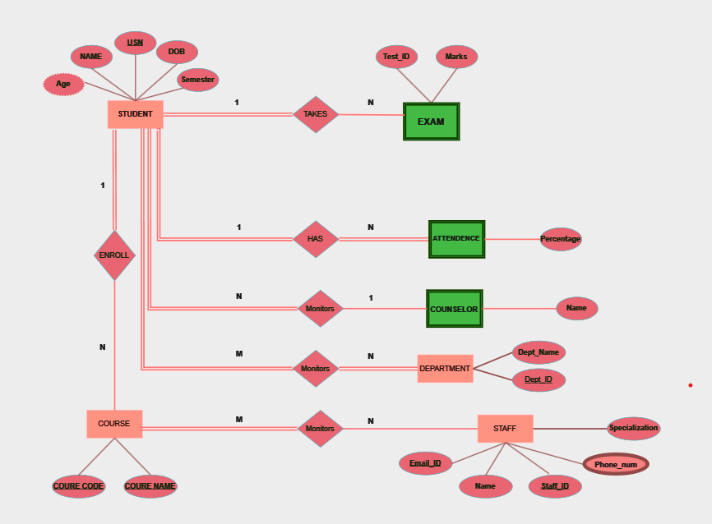

**Figure 3.1**

The Entity-Relationship (ER) Diagram for a Student Database Management System (DBMS) provides a detailed depiction of the system's structure, encompassing entities, relationships, attributes, and constraints. Within this diagram, entities like Student, Course, Faculty, Department, Grade, and Enrollment are represented, each with its set of attributes defining their properties. Relationships such as Enroll, Teach, and Belong To articulate the connections between entities, illustrating how students enroll in courses, faculty members teach courses, and students belong to academic departments. Constraints like primary keys ensure the uniqueness of entity instances, while foreign keys establish relationships between entities. Additionally, cardinality constraints specify the minimum and maximum number of instances in a relationship, offering insights into the nature of associations between entities. Through this ER diagram, the structure of the Student Database Management System is visually articulated, aiding in database design, implementation, and maintenance efforts.

Top of Form

**CHAPTER 04:**

**Detailed Design**

**Data Flow Diagram:**

DFD stands for Data Flow Diagram, which is a graphical representation of the flow of data through a system or process. DFDs are used to show how data moves from input sources, through processes, and to output destinations. They are commonly used in software engineering and systems analysis to help visualize and document the flow of data and processes in a system.

**4.1 DFD Level 0:**

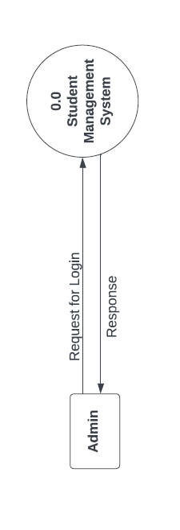

**Figure 4.1**

The Level 0 DFD provides an overview of the entire system without delving into the internal details of processes or data stores. It's a useful tool for stakeholders to understand the system's scope and major functionalities at a glance.

**4.2 DFD Level 1**

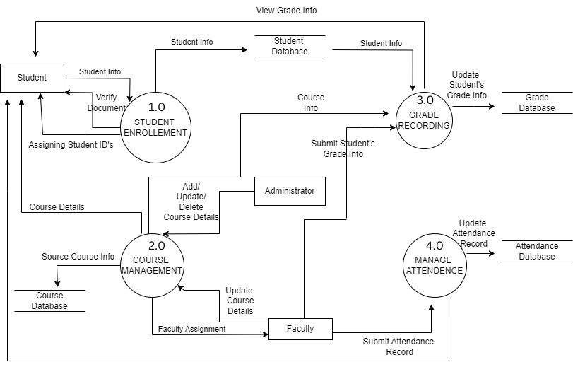**Figure 4.2**

In a Data Flow Diagram (DFD) Level 2 for a Student Database Management System (DBMS), each process from the Level 1 diagram is further decomposed into more detailed subprocesses, offering a granular view of the system's functionalities. For instance, within the "Manage Student Information" process, subprocesses like "Add Student," "Update Student Details," and "Delete Student" handle specific tasks such as registering new students, modifying existing records, and removing outdated entries. Similarly, processes under "Manage Course Information" such as "Add Course," "Update Course Details," and "Delete Course" deal with course-related operations like adding new courses, updating course details, and discontinuing courses. Additionally, subprocesses within "Generate Reports" manage the creation of various reports, including student transcripts, course schedules, and enrollment statistics. Data flows between these processes facilitate the movement of student and course information, ensuring accurate record-keeping and reporting. External entities such as students, faculty, and administrators interact with the system to enroll in courses, manage student records, assign grades, and access reports. The Level 2 DFD delineates the system's internal processes, data flows, and interactions with external entities within a comprehensive yet detailed framework, aiding in system analysis, design, and development efforts.

**4.3 DFD Level 2**

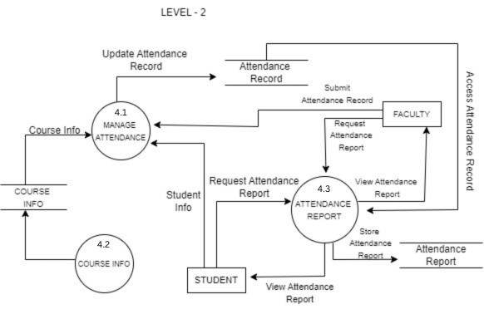

**Figure 4.3**

In a Data Flow Diagram (DFD) Level 3 for a Student Database Management System (DBMS), the system's processes are meticulously broken down into even more refined subprocesses, offering an intricate view of its functionalities. For instance, within the "Add Student" process, subprocesses like "Collect Student Information," "Validate Student Information," and "Create Student Record" handle

specific tasks such as gathering new student details, ensuring their accuracy, and finally adding them to the database. Similarly, processes like "Update Student Details" and "Delete Student" undergo detailed decomposition into actions such as modifying existing student records and removing them from the system, respectively. Each course management process, including "Add Course," "Update Course Details," and "Delete Course," is dissected into subprocesses responsible for tasks such as entering course information, validating it, and updating or deleting courses accordingly. Data flows between these processes are meticulously defined to ensure the smooth movement of student and course-related information throughout the system. Data stores such as the student and course databases play a central role in storing and managing this information, while external entities such as students, faculty, and administrators interact with the system to perform various tasks. The Level 3 DFD delineates the system's internal processes, data flows, and interactions with external entities with precision, offering invaluable insights for system development, optimization, and maintenance.

**CHAPTER 05:**

**Relational schema and Normalization**

**Schema diagram**

A schema diagram is a visual representation of a database schema, which shows the structure of a database system. The schema diagram typically includes tables, columns, primary and foreign keys, relationships, and constraints, among other things

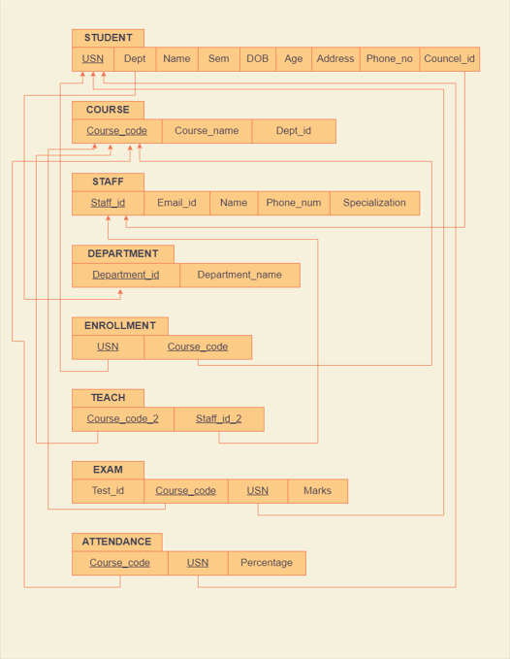

**Figure 5.1**

**Normalization and description**

Normalization refers to the process of organizing data in a database or other data storage structure in such a way that redundancy is minimized and data integrity is ensured. The aim of normalization is to eliminate redundant and duplicate data, and to prevent inconsistencies and anomalies from creeping into the data.

**1st Normal Form:**

This involves ensuring that each table has a primary key, and that each column in the table contains atomic (indivisible) values.

**Student Relation:**

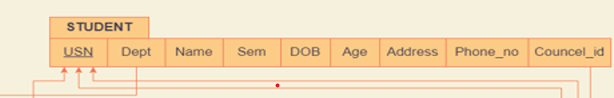

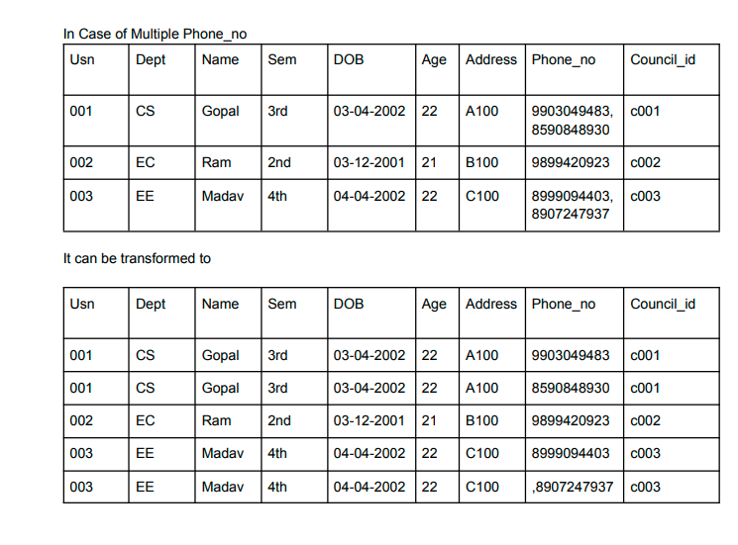

USN and Phone_no both are combined to form candidate key ===> **{USN,Phone_no}**

**Staff Relation:**

In Staff Relation

* It can have multiple Phone_num and multiple Specialization values.. Hence Staff_id, Phone_num and Specialization should be made as candidate key ====> **{Staff_id, Phone_num, Specialization}**

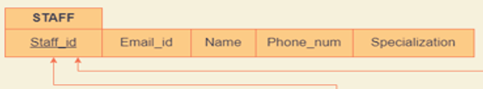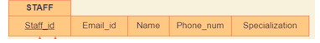

**2nd Normal Form:**

Conditions:

1. It should be in First Normal form.

2. It should not have any partial relationship.

**Student Relation:**

* Since USN and Phone_no is the candidate key they create partial dependency.

We can decompose the table into two tables as

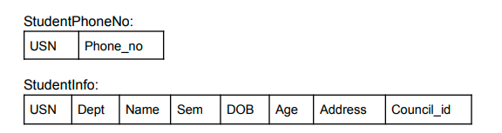

* USN and Phone_no both made as Candidate key in StudentPhoneNo table where USN is foreign key referring to Primary key of StudentInfo table.
* USN is made Candidate key in StudentInfo table.

**Staff Relation:**



* Since Staff_id,Phone_num and Specialization is the candidate key they create partial dependency

We can decompose the table into 2 tables as:

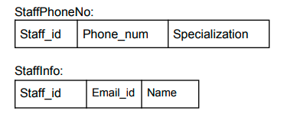

* Staff_id, Phone_num and Specialization are made as Candidate key in StaffPhoneNo table where Staff_id is foreign key referring to Primary key of StaffInfo table.
* Staff_id is made Candidate key in the Staff_Info table.

**CHAPTER 06:**

**NOSQL**

**Integrating NOSQL database to SQL with complete system architecture**

MongoDB is a document database with scalability and flexibility. MongoDB stores data in flexible, JSON-like documents, meaning fields can vary from document to document and data structure can be changed over time.

In this project to store images, mongoDB is the best as it allows to store unstructured data. The images of the student are stored in the database and retrieved to display to the user in jpg/png format. Also to fetch the images as a list for face recognition the module retrieves from the mongoDB server. Documents have attributes as USN and Image.

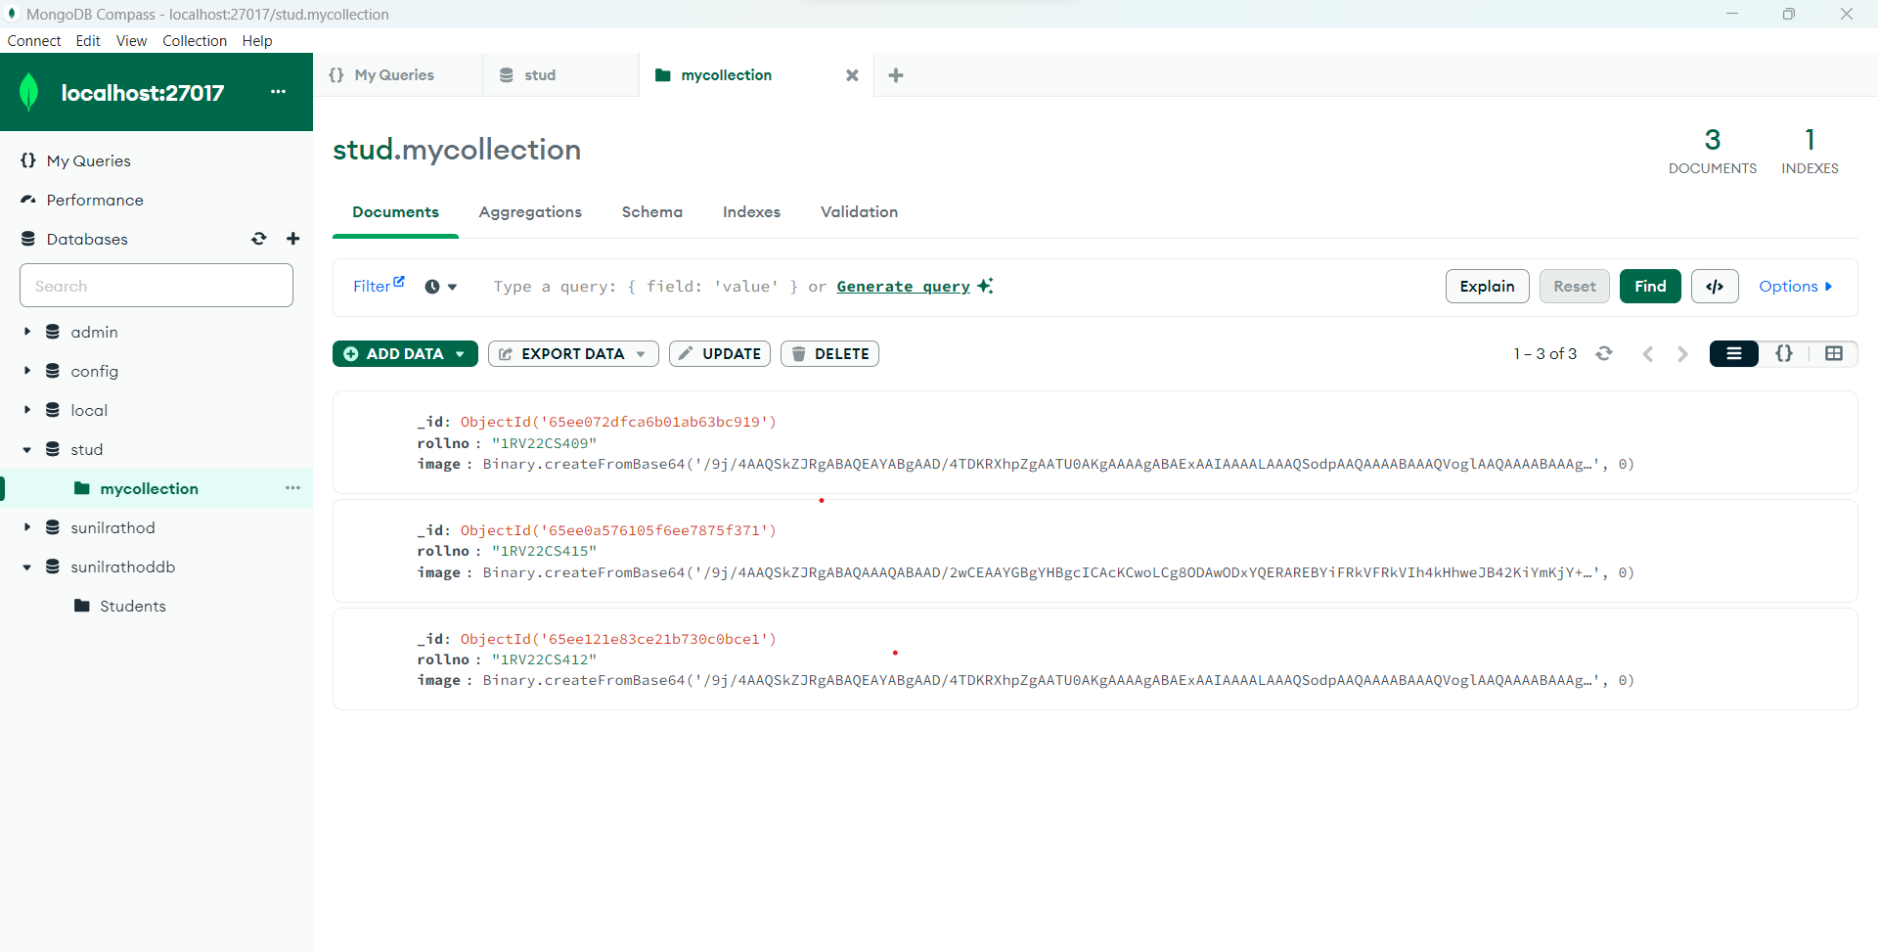

**Figure 6.1**

**CHAPTER 07:**

**Conclusion & Future Enhancement**

In conclusion, a student management system is a powerful tool that helps educational institutions manage various aspects of the student life cycle. From admission and enrollment to course management, grade management, and Attendance management, the system covers a wide range of activities and processes. The system streamlines operations, improves data accuracy, and facilitates communication between students, teachers, administrators, and parents. Additionally, the system can provide valuable insights through analytics and data visualization tools, helping educational institutions make informed decisions about student performance and academic programs.

The scope of a student management system can vary depending on the needs of the educational institution, but it can provide valuable benefits such as increased efficiency, improved data accuracy, and enhanced communication between students, teachers, administrators, and parents. A well-designed student management system can help educational institutions make informed decisions, support student success, enhance the overall educational experience for students and increase the efficiency of educational operations.

**Future Enhancement**

* Use of AI and ML for personalized recommendations and support.
* Mobile compatibility for on-the-go access.
* Integration with other educational tools.
* Real-time data analytics for informed decisions.
* Improved collaboration tools for better communication.
* Accessibility for all students, including those with disabilities.

These are just a few examples of the many possible enhancements that can be made to student management systems in the future. Ultimately, the goal should be to create a platform that is user-friendly, efficient, and provides students, teachers, and administrators with the tools they need to achieve success.

**References**

[1] Siddiqui, M. A., & Alam, M. M. (2019). Design and implementation of a web-based student management system for educational institutions. IEEE International Conference on Advances in Electrical Engineering (ICAEE), 330-333. doi: 10.1109/ICAEE.2019.8710076

[2] Garg, N., & Gupta, R. (2016). A cloud-based student management system using NoSQL database. IEEE International Conference on Computing, Analytics and Security Trends (CAST), 1-5. doi: 10.1109/CAST.2016.7579563

[3] Alqurashi, A., & Alshammari, R. (2018). A comparative study of student management systems in higher education institutions. IEEE Access, 6, 46994-47008. doi: 10.1109/ACCESS.2018.2866548

[4] Wang, X., Zhang, L., & Xie, H. (2016). A personalized student management system based on big data analysis. IEEE International Conference on Big Data Intelligence and Computing (DataCom), 528-533. doi: 10.1109/DataCom-ICC.2016.7844805

[5] Raza, M. T., & Ali, S. (2018). Design and development of a student management system using RFID technology. IEEE Access, 6, 36206-36214. doi: 10.1109/ACCESS.2018.2843113

[6] Lee, S., Lee, D., & Kim, K. (2017). A student management system for small-scale education institutes using Raspberry Pi. IEEE International Conference on Consumer Electronics (ICCE), 1-2. doi: 10.1109/ICCE-China.2017.7996642

**Snapshots**

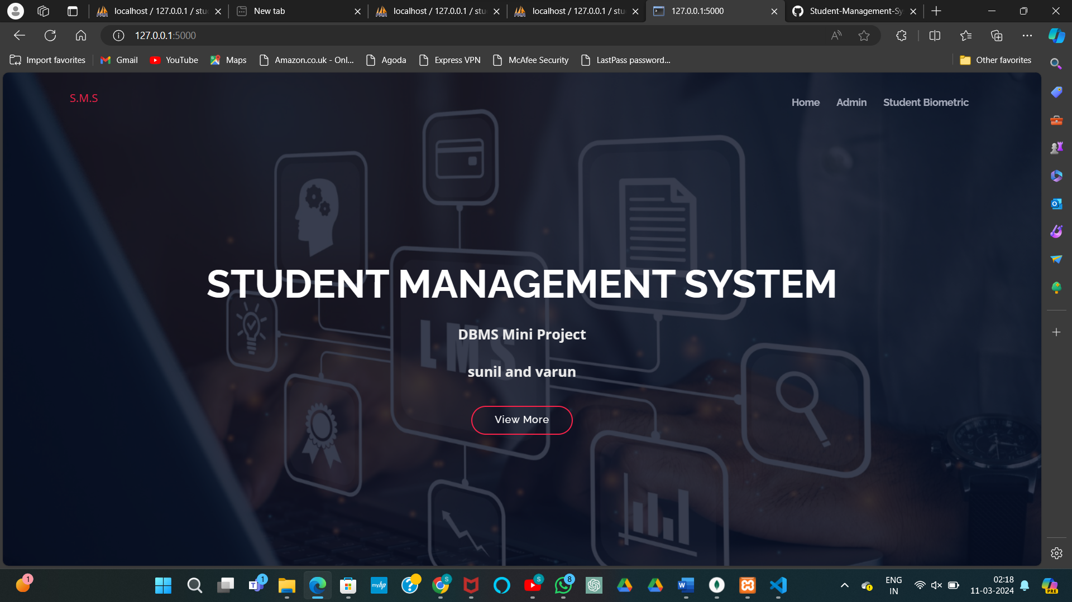

User Login: - User can login and enter in the page, to login, users must have login credentials.

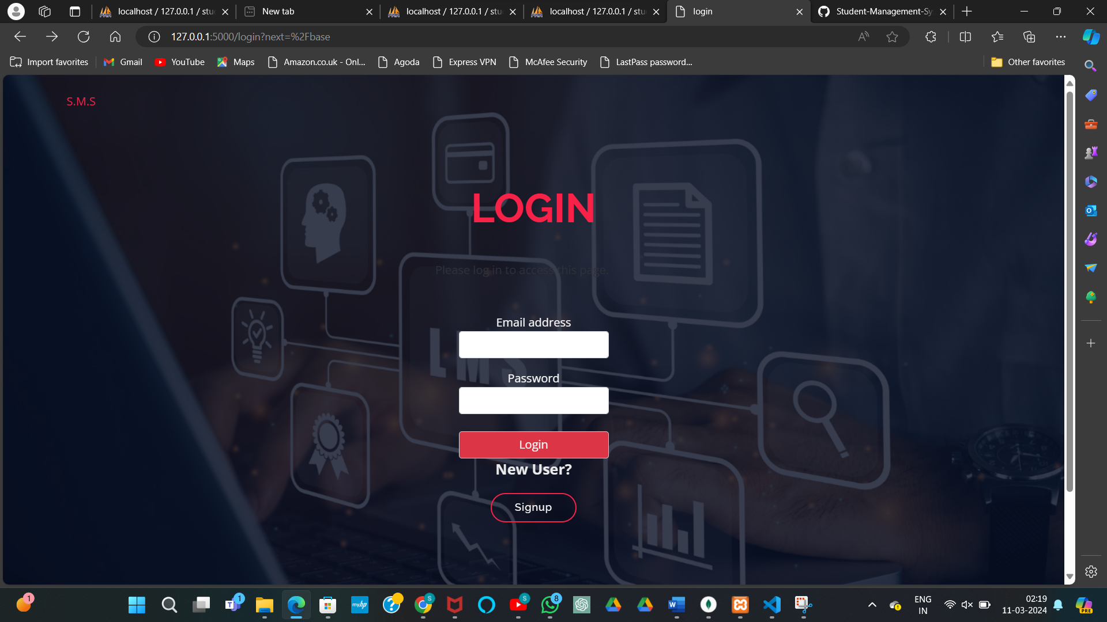

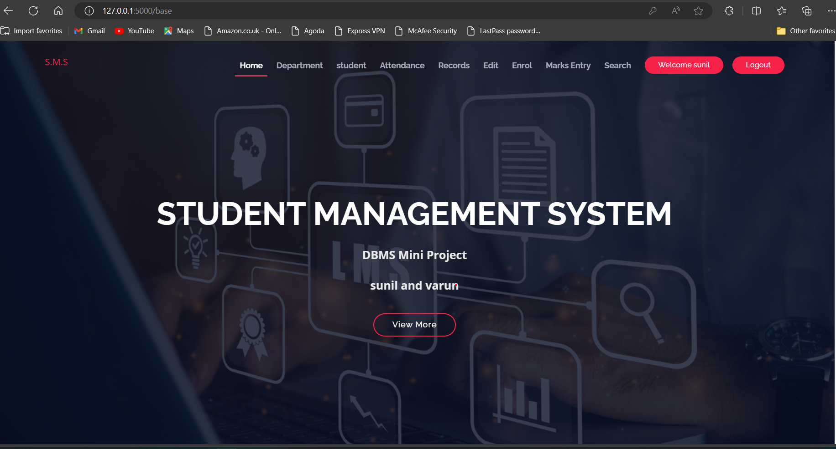

Student Details: In this page we can add the student details, the system can store and manage student information such as personal details, academic records and contact information.

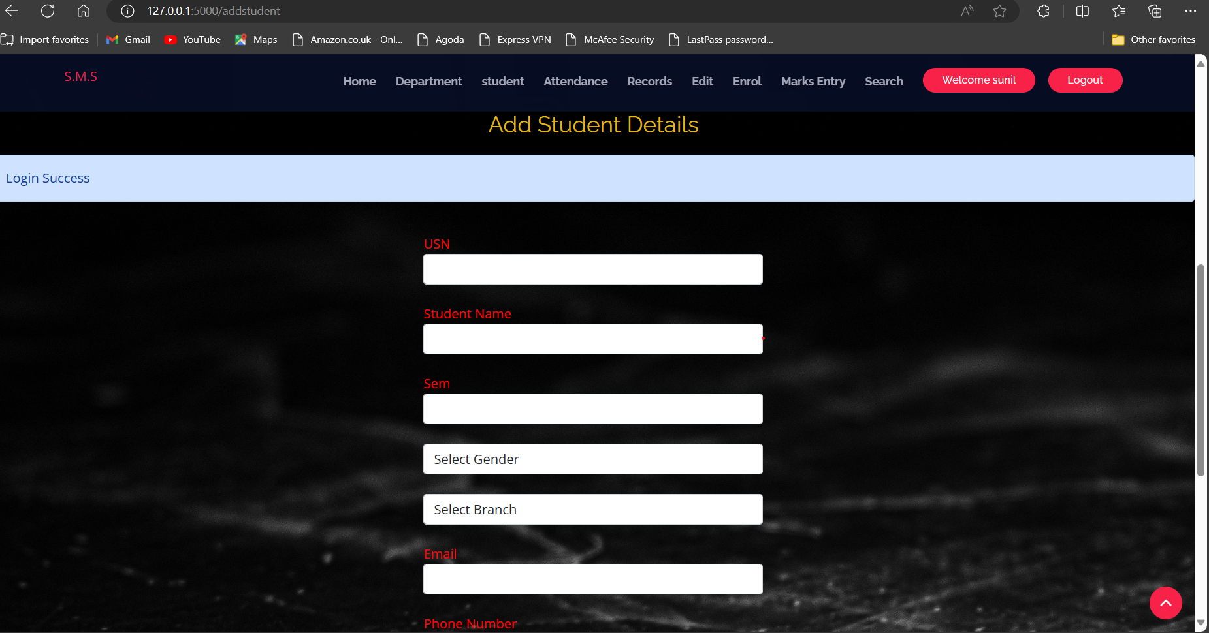

Attendance Management: In this page we can add student attendance details, the system can track attendance and generate reports on attendance trends.

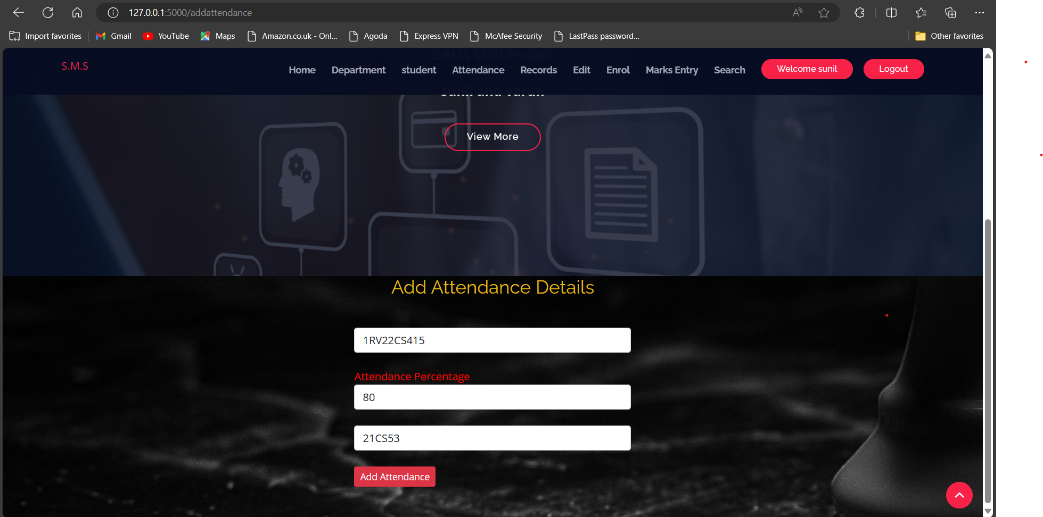

Edit: In this page we can edit the records of student and we can also delete the student records

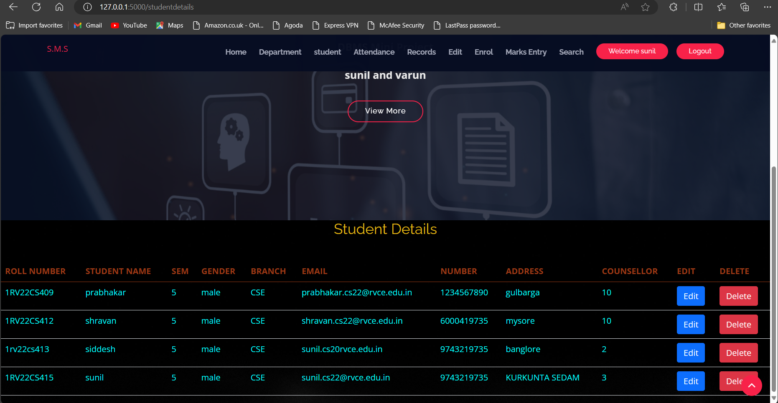

Records: In this we can view the records of the student with the timestamp.

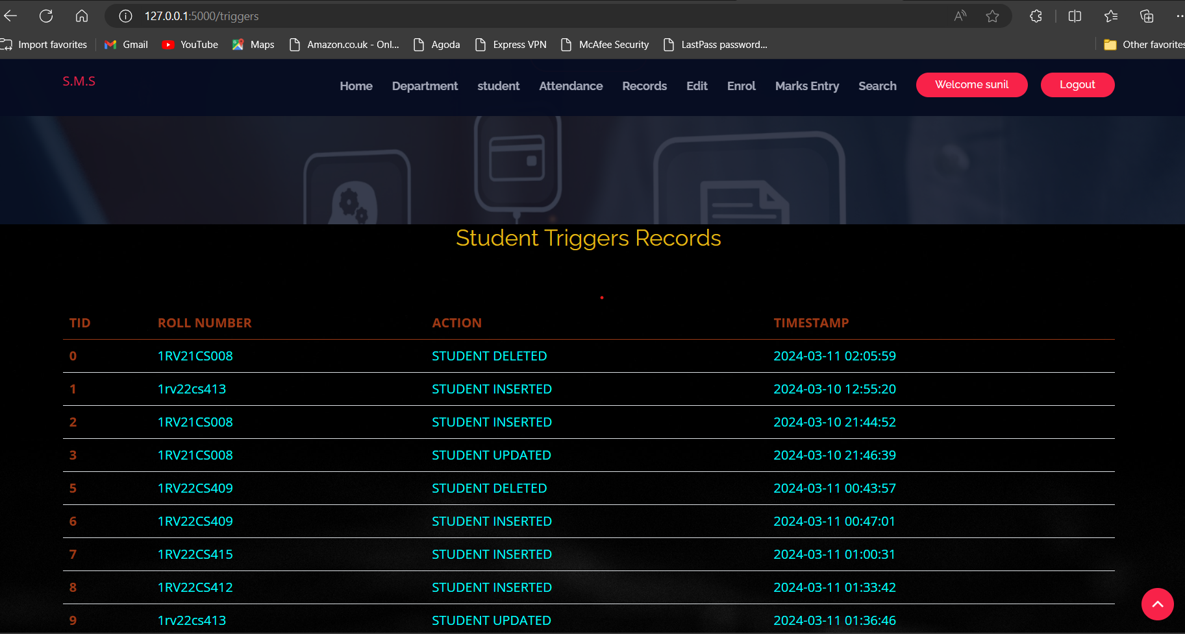

Enrollment: In this page we can enroll the student in the course.

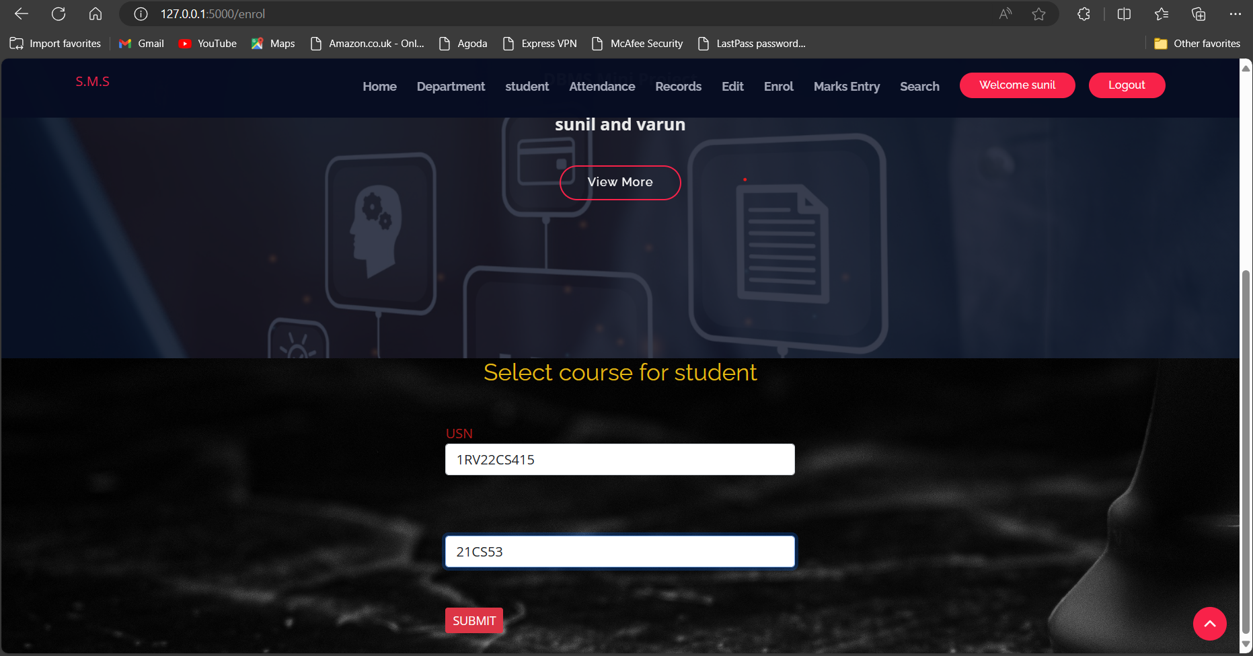

Grade Management: In this page we can add the student marks in the particular course, The system can store and manage grades and other academic data and generate reports.

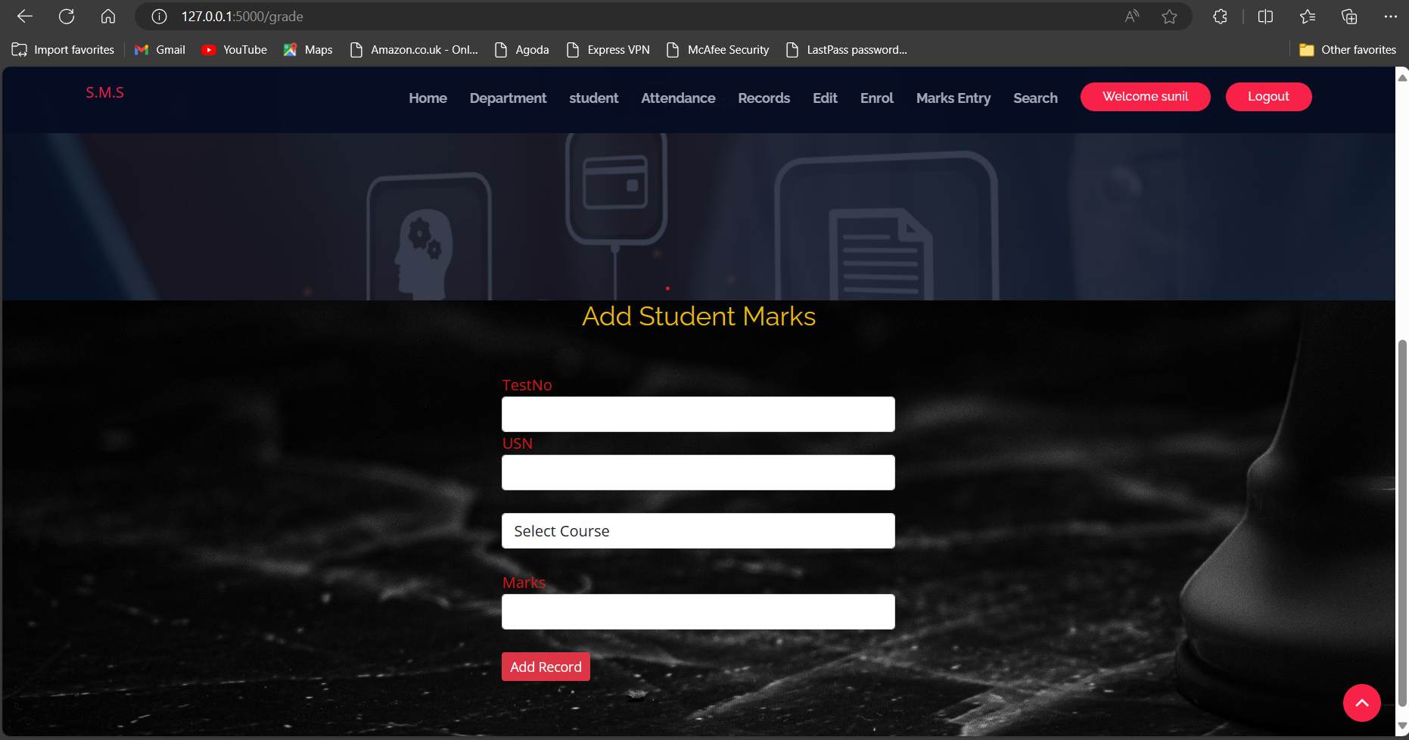

Search:- In this page we can retrieve the student details, such as student personnel information, attendance details, course enrollment details and grades,

